**IMPLEMENTING NOTIFICATIONS FROM POSTGRESQL TO BACKEND SERVER**

IN ORDER TO ACHIEVE THIS GOAL, WE HAVE TO DO NEXT:

REF:

<http://coussej.github.io/2015/09/15/Listening-to-generic-JSON-notifications-from-PostgreSQL-in-Go/>

<http://django-tornado-websockets.readthedocs.io/en/latest/installation.html>

1. ONCE POSTGRESQL INSTALLED IN OUR UBUNTU SERVER AND CONNECTED WITH VAGRANT, WE HAVE TO ENSURE WE HAVE ALREADY INSTALLED ***pg_notify*** MODULE IN OUR POSTGRESQL SERVER AND THE CREATE A TRIGGER LINKED TO AN SPECIFIC TABLE TO BE EXECUTED AFTER INSERT UPDATE AND DELETE ACTIONS

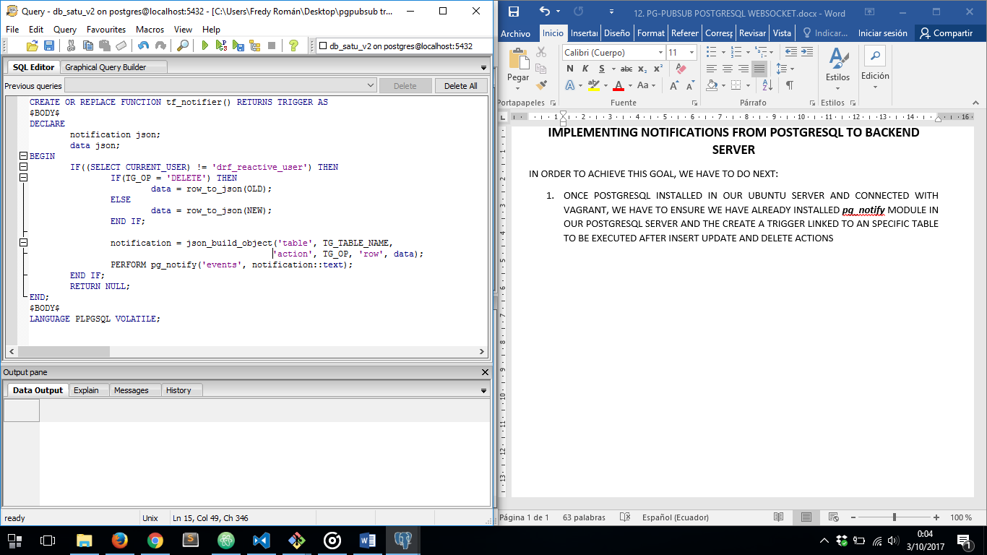

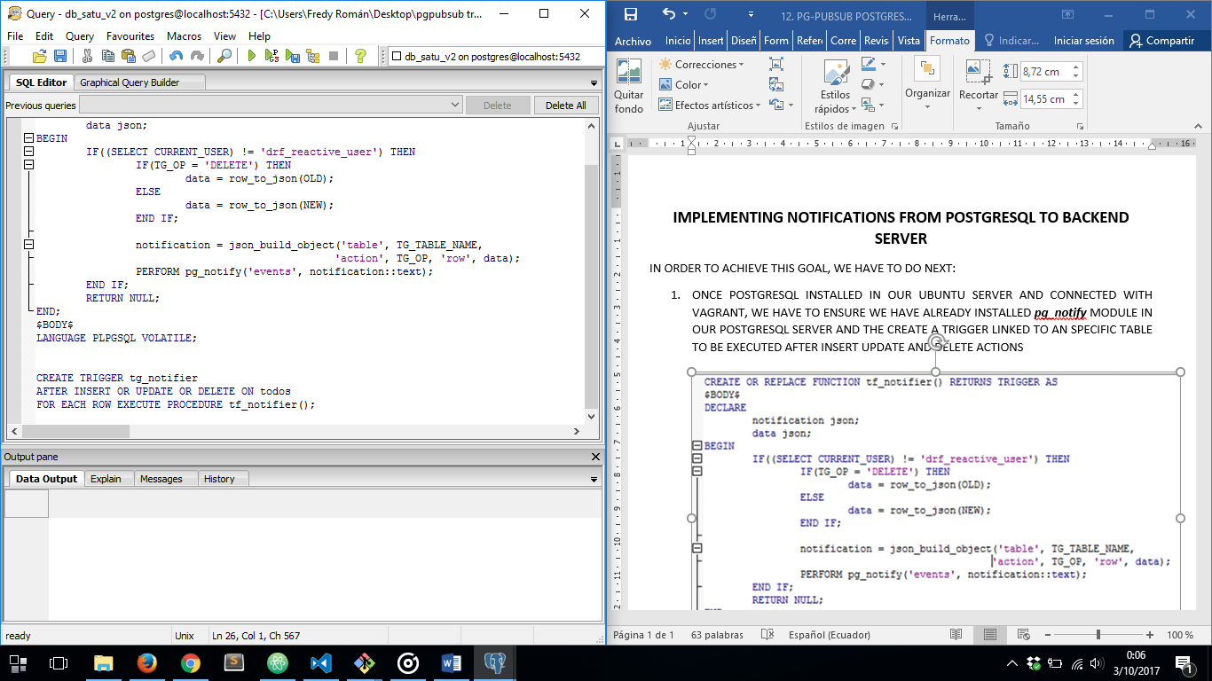

THEN WE HAVE TO BE SURE OUR NOTIFIER WORKS WELL, SO WE HAVE TO CREATE A PYTHON SCRIPT TO CATCH POSTGRESQL NOTIFICATIONS

1. INSTALL ***pgpubsub*** USING ***pip install*** ONCE ACTIVATED OUR PYTHON VIRTUAL ENVIRONMENT:

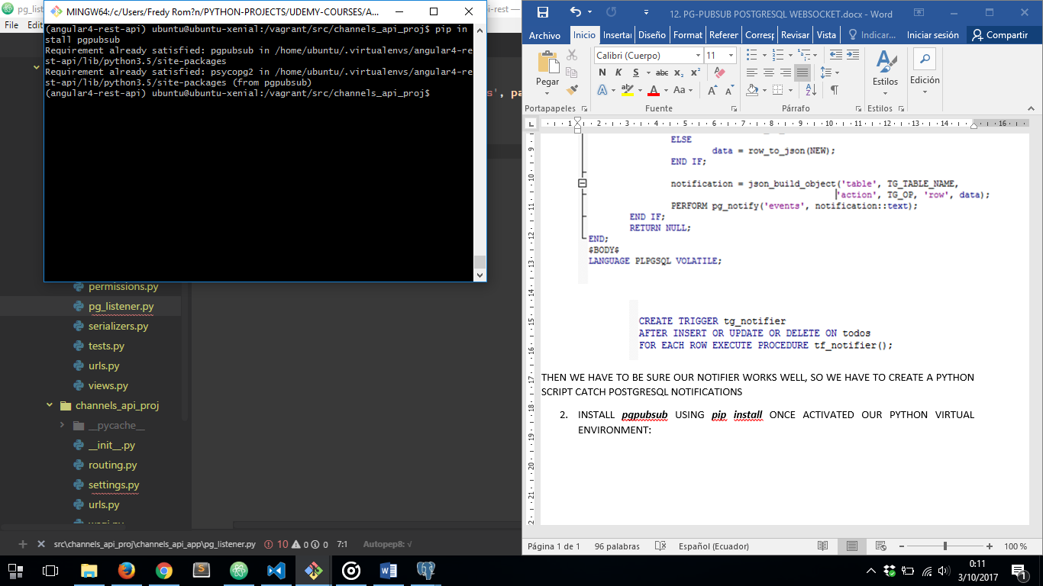

1. CREATE A SCRIPT TO CATCH NOTIFICATIONS FROM DATABASE:

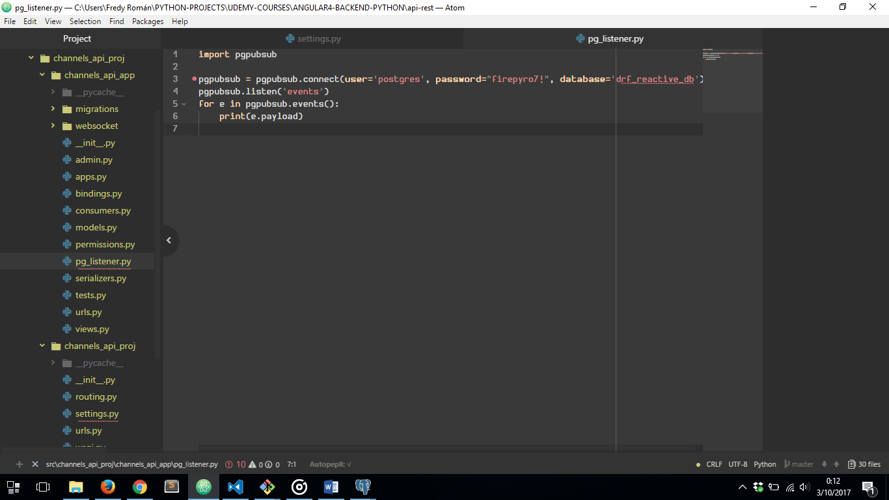

1. RUN SCRIPT

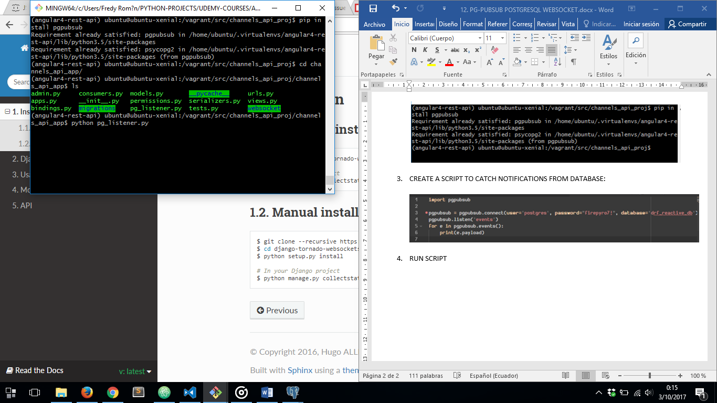

1. GENERATE TRIGGER NOTIFICATION FROM PSQL:

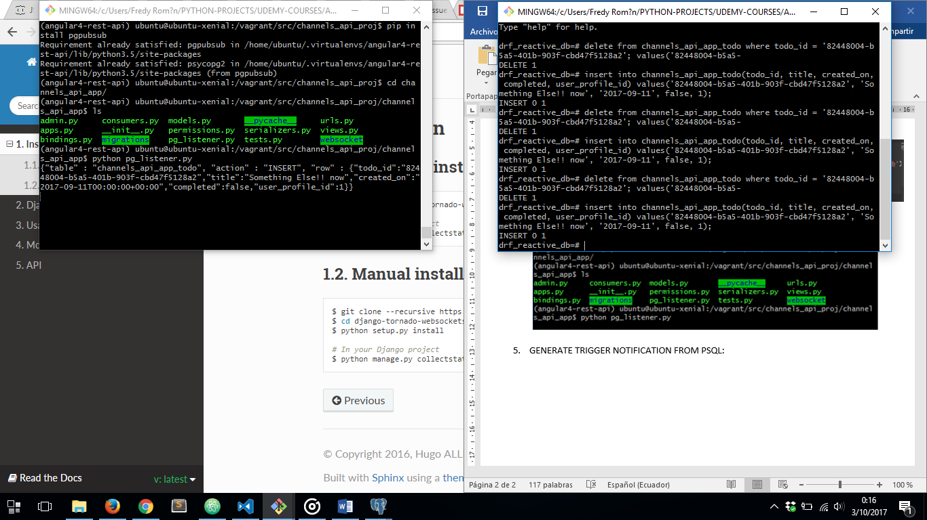

1. SEE NOTIFICATIONS COMMING TO PYTHON SCRIPT



NOW WE ARE SURE NOTIFICATIONS ARE COMMING FROM POSTGRESQL, LETS INCORPORATE WEBSOCKETS TO SEND THOSE NOTIFICATIONS TO SOME FRONTEND CLIENT

1. INSTALL ***django-tornado-websockets*** LIBRARY USING ***pip install***

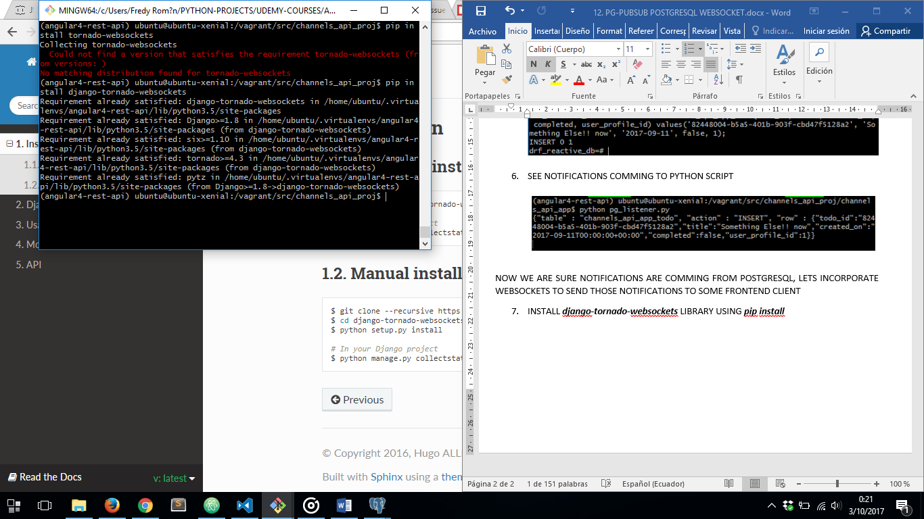

1. ADD TORNADO WEBSOCKETS INSIDE INSTALLED_APPS IN ***settings.py***

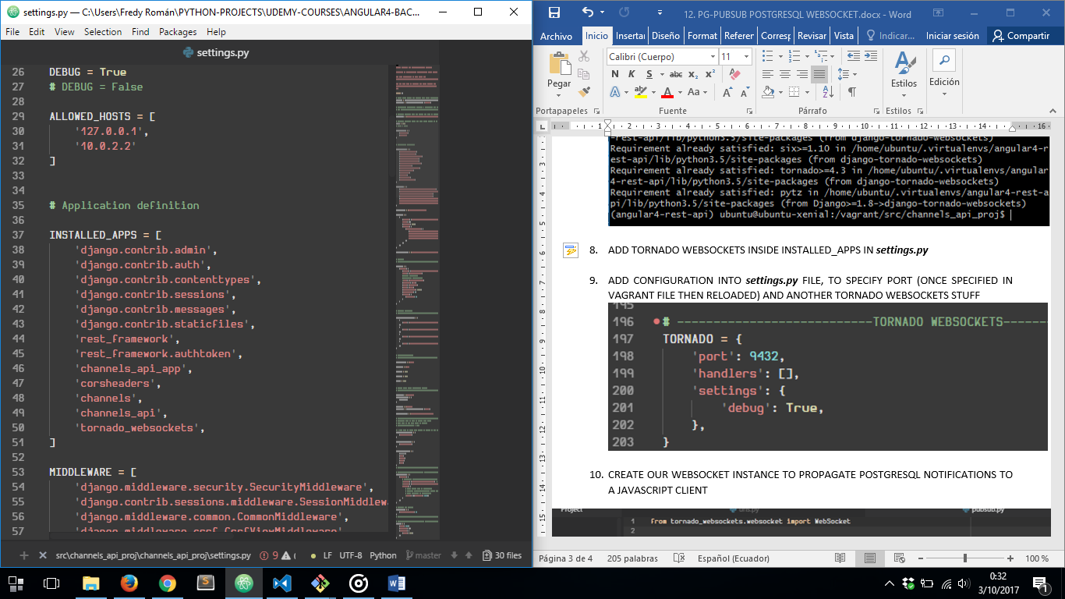

1. ADD CONFIGURATION INTO ***settings.py*** FILE, TO SPECIFY PORT (ONCE SPECIFIED IN VAGRANT FILE NOW RELOADED) AND ANOTHER TORNADO WEBSOCKETS STUFF

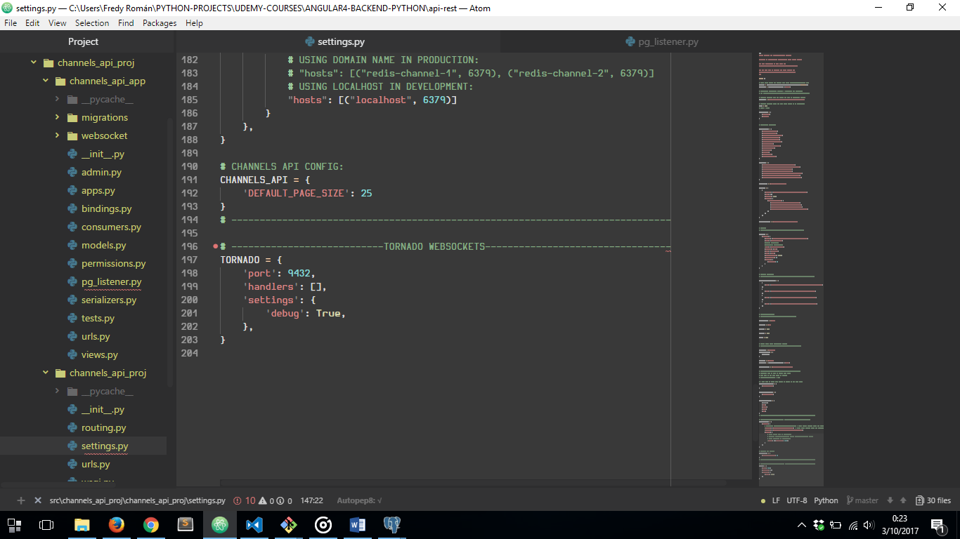

1. 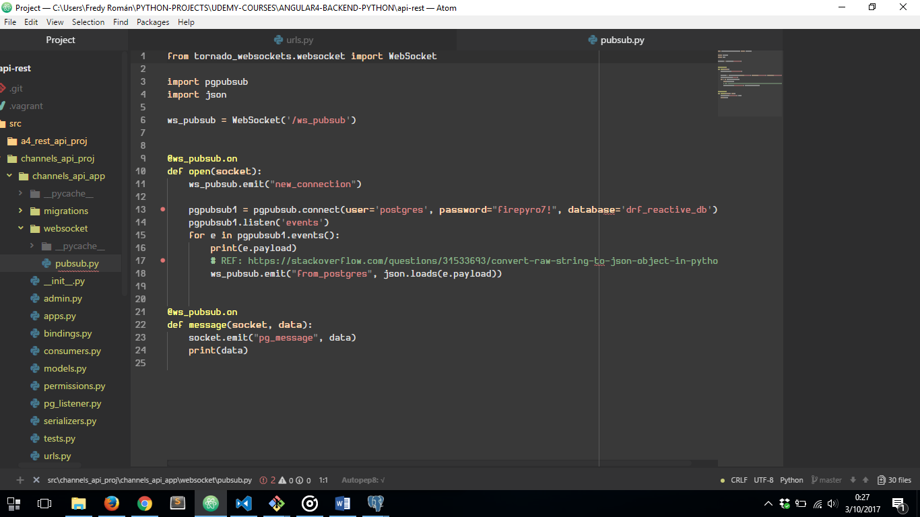CREATE OUR WEBSOCKET INSTANCE TO PROPAGATE POSTGRESQL NOTIFICATIONS TO A JAVASCRIPT CLIENT
2. AFTER THAT WE HAVE TO CALL ***pubsub.py*** INSIDE OUR ***views.py*** FILE

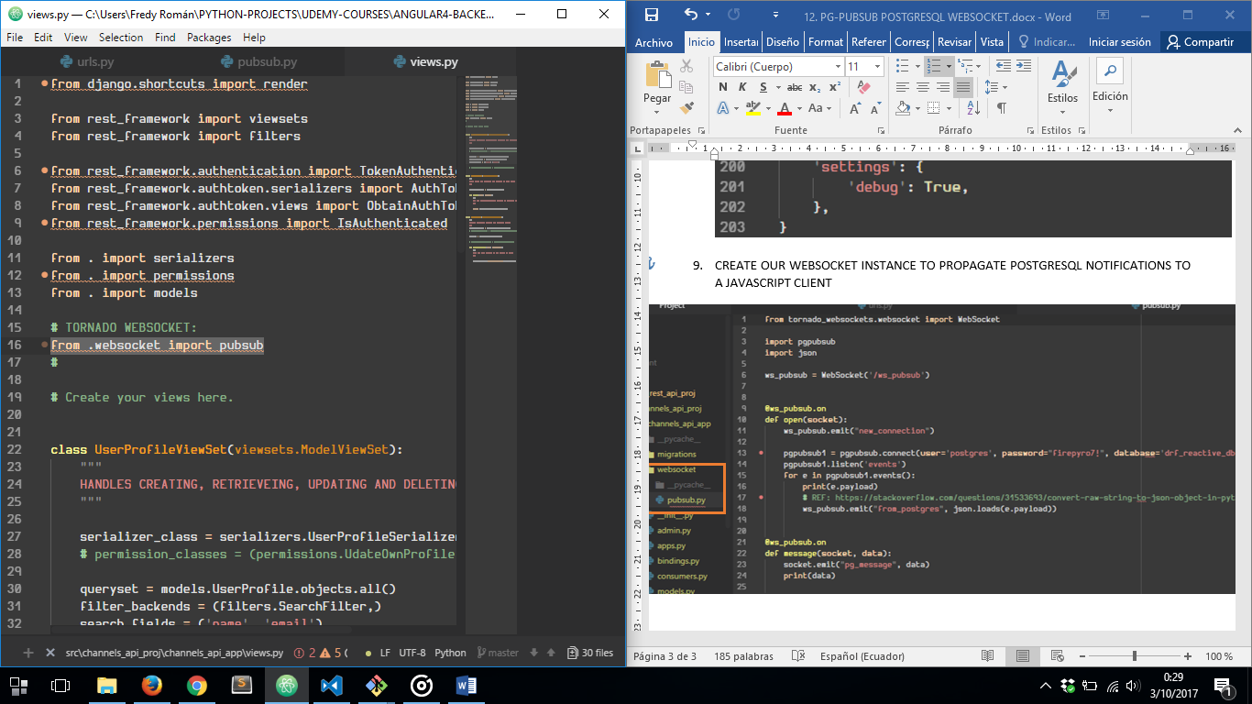

1. FINALLY WE NOW ARE ABLE TO DEPLOY OUR TORNADO WEBSOCKET SERVER:

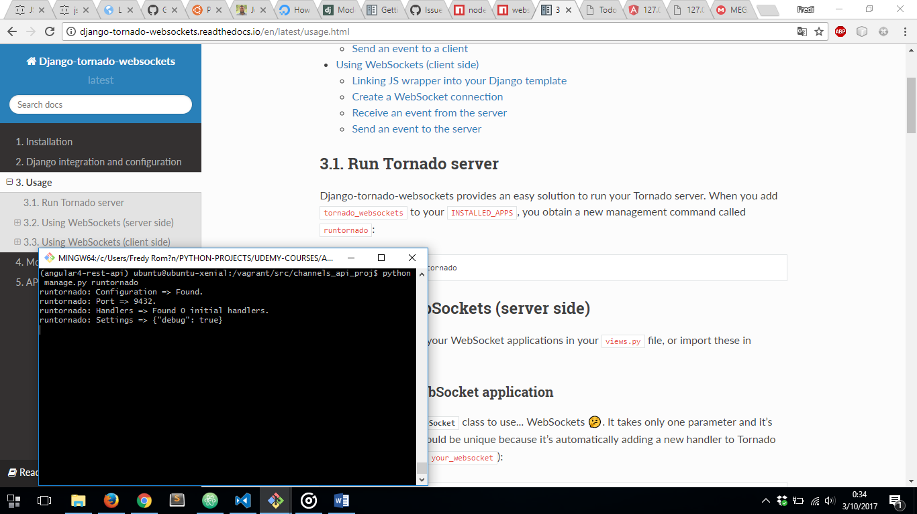

NOW WE CAN CREATE A JAVASCRIPT CLIENT TO CATCH EVENTS SEND FROM TORNADO WEBSOCKET WHICH HAVE BEEN TAKEN FROM POSTGRESQL EVENTS